# Day 12

**Task 1: Bit Manipulation Basics**

Create a function that counts the number of set bits (1s) in the binary representation of an integer. Extend this to count the total number of set bits in all integers from 1 to n.

**Program:**

package Assignments.Day12;

public class Task1 {

static int countSetBits(int n)

{

int bitCount = 0;

for (int i = 1; i <= n; i++)

bitCount += countSetBitsUtil(i);

return bitCount;

}

static int countSetBitsUtil(int x)

{

if (x <= 0)

return 0;

return (x % 2 == 0 ? 0 : 1)

+ countSetBitsUtil(x / 2);

}

public static void main(String[] args)

{

int n = 4;

System.out.print("Total set bit count is ");

System.out.print(countSetBits(n));

}

}

**Output:**

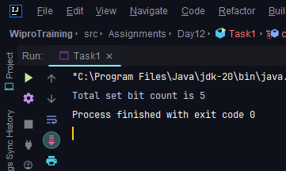

**Task 2: Unique Elements Identification**

Given an array of integers where every element appears twice except for two, write a function that efficiently finds these two non-repeating elements using bitwise XOR operations.

**Program:**

package Assignments.Day12;

import java.util.*;

public class Task2 {

public static int[] get2NonRepeatingNos(int[] nums) {

int diff = 0;

for (int num : nums) {

diff ^= num;

}

diff &= -diff;

int[] rets = new int[2];

Arrays.fill(rets, 0);

for (int num : nums) {

if ((num & diff) == 0) {

rets[0] ^= num;

} else {

rets[1] ^= num;

}

}

if (rets[0] > rets[1]) {

int temp = rets[0];

rets[0] = rets[1];

rets[1] = temp;

}

return rets;

}

public static void main(String[] args) {

int[] arr = {2, 3, 7, 9, 11, 2, 3, 11};

int[] result = get2NonRepeatingNos(arr);

System.out.println("The non-repeating elements are " + result[0] + " and " + result[1]);

}

}

**Output:**

